RUNNING HEAD: DEVELOPMENT OF ANIMAL CATEGORY

When Humans Become Animals:
Development of the Animal Category in Early Childhood
Patricia A. Herrmann, Douglas L. Medin, Sandra R. Waxman
Northwestern University

Word Count: 3,004
Author Note:
This research was supported by the National Science Foundation under Grants BCS 0745594 and DRL 0815020, to the second and third authors.
Correspondence concerning this article should be addressed to Patricia A. Herrmann, Department of Psychology, Northwestern University, 2029 Sheridan Rd., Evanston, IL 60208. Email: p-herrmann@northwestern.edu, Phone: (847) 707-2668, Fax: (847) 491-7859
Abstract
The current study examines 3- and 5-year-olds’ representation of the concept we label ‘animal’ and its two nested concepts – animal_{contrastive} (including only non-human animals) and animal_{inclusive} (including both humans and non-human animals). Building upon evidence that naming promotes object categorization, we introduced a novel noun for two distinct objects, and analyzed children’s patterns of extension. In Experiment 1, children heard a novel noun in conjunction with two non-human animals (dog, bird). Here, both 3- and 5-year-olds readily accessed animal_{contrastive} and extended the noun systematically to other (previously un-named) non-human animals. In Experiment 2, children heard a novel noun in conjunction with a human and non-human animal. Here, 5-year-olds (but not 3-year-olds) accessed animal_{inclusive} and extended the noun systematically to humans and non-human animals. These results underscore the developmental challenge facing young children as they identify the scope of the fundamental biological term ‘animal’ and its corresponding, nested concept(s).
Keywords: cognitive development; folk-biology; categorization
“All animals are equal but some animals are more equal than others.”
- George Orwell
1. Introduction
What is an animal? For English-speaking adults, there are at least two interpretations of this fundamental biological term. ‘Animal’ can refer either to an inclusive concept, including all animate beings (as in, “Animals have babies”), or to a more restricted concept, including non-human animals but excluding humans (as in, “Don’t eat like an animal”). For ease of exposition, we will refer to these two nested concepts, respectively, as animal_{inclusive} and animal_{contrastive} (See Waxman, 2005). Although this polysemous use of ‘animal’ is endemic in everyday conversation, it only rarely presents interpretive challenges to adult speakers, particularly because the context in which ‘animal’ is used provides strong cues about which sense is intended.
For infants and young children, however, the interpretive challenge is more severe (Waxman, 2005). There is evidence that infants and children include both humans and non-human animals in a concept organized around animacy or agency (Massey & R. Gelman, 1988; Opfer & S. Gelman, 2010; See Luo, Kaufman & Baillargeon, 2009 for discussion). However, children seem to have no dedicated name for this overarching concept. (See Berlin, 1972 for discussion of unnamed (or covert) concepts). Moreover, they overwhelmingly interpret ‘animal’ in the contrastive sense. For example, when asked to name “…all the animals you can think of”, 5-year-old children named a wide variety of animals, ranging from mammals to insects, but not a single child included humans (or ‘people’) in their list (Winkler-Rhoades, et al., 2010). Further, when 3- and 5-year-olds are explicitly asked whether “…humans are animals”, they overwhelmingly respond in the negative (Leddon, et al., under review). Clearly, then, young English-speaking children favor the contrastive sense of the fundamental biological term ‘animal’.
Research reveals that young children have access to certain core biological concepts (e.g., alive), but that their competence is masked when they do not map words to them in the same way as adults. For example, children acknowledge that humans, non-human animals and plants are all ‘living things’, yet fail to classify them together under the term ‘alive’ (Leddon, Waxman & Medin, 2008). This insight may be relevant to the acquisition of the concept animal_{inclusive.} Perhaps young children appreciate an overarching concept that includes both humans and non-human animals (animal_{inclusive}), but fail to demonstrate this appreciation because they have mapped the term ‘animal’ to animal_{contrastive}.
In this paper, we ask whether, and under what circumstances, young children can engage the overarching animal_{inclusive} concept. To address this question, we take advantage of strong developmental evidence that object naming and categorization are linked (Waxman and Gelman, 2009 provide a review). From infancy, providing the same name for a set of distinct individuals (e.g., dog, duck) highlights commonalities among objects that might otherwise have gone undetected (Waxman, 1989; Waxman & Markow, 1995) and supports the use of these categories in reasoning (Gelman & Markman, 1987; Waxman, Lynch, Casey, Lyman & Baer, 1997; Welder & Graham, 2001).
This link between naming and categorization provides us with an opportunity to explore children’s representations of both a contrastive and an inclusive category of animal. We focus on 3- and 5-year-olds because previous studies have found changes in biological reasoning during this period of conceptual development, (e.g. Herrmann, Waxman & Medin, 2010; Jipson & Gelman, 2007; Slaughter & Lyons, 2002; Waxman, Ross & Medin, 2007). We consider children’s facility accessing two nested concepts -- animal_{contrastive} and animal_{inclusive} -- across this period. In each experiment, we present children with two distinct training-items, label them with the same novel noun, and probe children’s extensions of that noun to a range of other entities. In Experiment 1, both training-items are non-human animals; in Experiment 2, training-items include one human and one non-human animal. We use children’s extensions of the novel noun to gain insight into the breadth of their underlying concepts. At issue is whether they will include humans and non-human animals together as members of the same overarching animal_{inclusive} concept.
2. Experiment 1
We introduce 3- and 5-year-old children to a novel noun for two non-human animals – a bird and a dog – and examine their extension of that noun to a range of other entities, including humans, non-human animals, and inanimate objects (plants, non-living natural kinds and artifacts). We predict that both 3- and 5-year-olds will systematically extend the novel noun beyond the named training-items to include other non-human animals, but will exclude the inanimate objects. At issue is whether they will spontaneously extend the noun to include humans along with non-human animals.
2.1. Participants
Twenty-seven typically developing 5-year-olds (13 girls), ranging from 60 to 72 months (M = 66.36), and 28 typically developing 3-year-olds (12 girls) ranging from 37 to 47 months (M = 39.36) were recruited from the Chicago area. They were drawn either from a Chicago public school serving a diverse population (40% Black, 24 % Asian, 19% Hispanic, 17% Caucasian) or from a neighboring town (70% Caucasian). Performance in these two locales did not differ. Two additional children (one 5-year-old; one 3-year-old) were excluded for failing to meet the inclusion criteria (described below).
2.2. Materials
Materials included 23 laminated photographs depicting humans, non-human animals, and inanimate objects (plants, non-living natural kinds, artifacts). See Table 1.
------------------------------------------------------------------------------------------
Table 1. Training and Test Items used in Experiments 1 and 2.

Training Pairs Test Items
Experiment 1 Human _{male} Bee
(Dog, Bird) Human _{female} Ant
Dog Tree
Bird Plant
Experiment 2 Bear Rock
(Human_{male}ª, Dog) Squirrel Sun
(Human_{male}, Bird) Deer Watch
Turtle Pencil
Snake Cup
Fish Ball
ªTwo different male humans, one Caucasian and one Asian, were randomly assigned to training- or test-item for each subject. The female human was African-American.
------------------------------------------------------------------------------------------
2.3. Procedure
The child was seated across a table from the experimenter in a quiet testing room. To begin, the experimenter presented each item, in random order, asking the child to identify the object it depicted. If the child responded incorrectly, the experimenter identified it (e.g., “It’s a (dog), okay?”)
Next, the experimenter introduced a hand-puppet (Pinky), explaining that Pinky lived far away and used “…funny words for things”. The experimenter then pointed to the two training-items (dog, bird) in random order, saying, “Pinky calls these both blickets. This one is a blicket and this one is a blicket”. The experimenter then presented each test photograph in random order, asking “Does Pinky call this one a blicket?” Mid-task, the experimenter pointed to each of the two training-items, asking “Does Pinky call this one a blicket?” Any child who failed to identify the training photographs as blickets at the mid-task recall was excluded from further analysis.
Coding and Analysis: Children’s responses were catalogued either as 1’s (signifying a “yes” response) and 0’s (signifying “no”). As a measure of internal consistency, coefficient alpha was calculated for each group of test-items (humans, non-human animals, inanimates). Consistency was high within each: humans (α=0.88), non-human animals (α=0.85), inanimates (α=0.84).
We analyzed the data in two ways. First, we considered mean patterns of performance. Second, we examined each individual child’s response pattern.
2.4. Results and Discussion
As predicted, both 3- and 5-year-old children extended the novel noun to the test-items that matched the training-items and to the other non-human animals, excluding the inanimate entities. But neither the 3- nor 5-year-olds extended the novel noun to include humans. See Figure 1.
Mean response patterns.
An ANOVA with Age (2: 3- & 5-year-olds) as a between-participants factor and Target Kind (5: dog, bird, humans, non-human animals, inanimates) as a within-participants factor revealed only a main effect of Target Kind, F(4, 212) = 69.93, p < .001, η² = .57. Children were more likely to extend the novel noun to the test-items that matched those used in training (dog, birds) than to any other target kinds (humans, nonhuman animals, inanimates, all p’s < .001). Crucially, children were more likely to extend the novel noun to non-human animals than to either the inanimates, p < .001, or humans, p < .001. There was no difference between extensions to humans and inanimates; responses to both of these target kinds were below chance levels, t(54) = -3.41, p < .01, and t(54) = -5.64, p < .001, respectively.
We supplemented these analyses with Generalized Estimating Equations (GEE), specifically designed to handle dichotomous (yes-no) data. These results converged with the more traditional parametric analyses reported above.
Individual Response Patterns
We next asked whether the responses of individual children mirrored the patterns revealed in the mean analysis. We considered three distinct patterns: animal-contrastive (non-human animals only), animal-inclusive (human and non-human animals) and training-items only (dog and bird only). We adopted a stringent criterion, including only those children whose responses conformed to a given patterns with no more than a single inconsistency across the entire set of test items. This was satisfied by 11 3-year-olds (41%) and 12 5-year-olds (44%). At both ages, the predominant individual pattern was the animal-contrastive pattern, exemplified by 9 3-year-olds and 10 5-year-olds (82% and 83% of those included at each age, respectively). The animal-inclusive pattern was rare: entirely absent in 3-year-olds and displayed by only 1 5-year-old. The training-items only pattern was also rare, evident in only 2 3-year-olds and 1 5-year-old. These results converge with the mean patterns of analyses to suggest that 3- and 5-year-olds overwhelming relied on an animal_{contrastive} category to extend the novel noun.

------------------------------------------------------------------------------------------
Figure 1. Experiment 1. Three- and 5-year-olds’ extension of the novel word to test-items in 5 categories: each training-item match (dog & bird), humans, the remaining non-human animals, and inanimates. Children’s responses to the test-items that matched the training-items are depicted on the left. *p < .01 compared with chance (0.5), 2-tailed t-test.
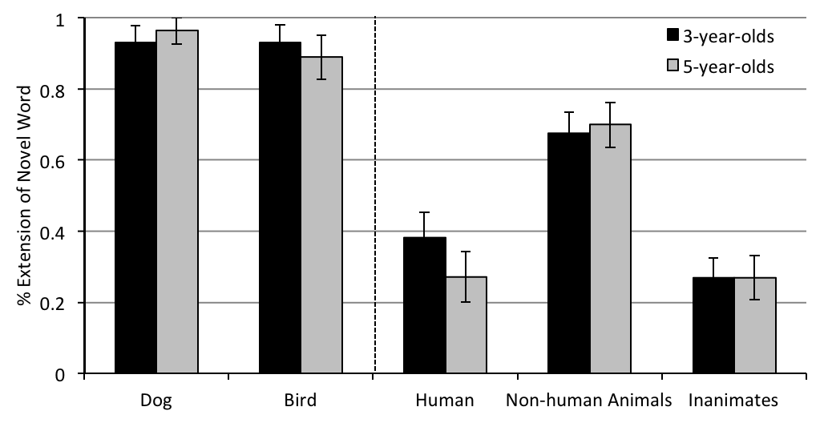
*
*
*
*
*
*
*
*
*
------------------------------------------------------------------------------------------
These results provide assurance that children understood the demands of this task and were able to respond systematically. When 3- and 5-year-olds were introduced to a novel noun for two distinct non-human animals, they systematically extended that noun to other non-human animals, but excluded humans and inanimate entities. This mirrors previous work documenting children’s strong representation of animal_{contrastive} (Angorro, Waxman & Medin, 2008; Coley, 2007; Herrmann, et al., 2010; Johnson, Mervis & Boster, 1992; Rhodes & Gelman, 2009). Notice, however, that the fact that children favor an animal_{contrastive} category does not preclude the possibility that they also represent the more inclusive sense. In Experiment 2, we pursue this possibility directly.
3. Experiment 2
Experiment 2 is identical to Experiment 1 with one exception: We introduced children to a novel noun for a human and a non-human animal (either a bird or a dog). We reasoned that if 3- and 5-year-olds do have access to animal_{inclusive}, they should engage it in this context.
3.1. Participants
Fifty-four typically developing 5-year-olds (27 girls), ranging from 60 to 72 months (M = 66.78), and 55 typically developing 3-year-olds (28 girls) ranging from 36 to 48 months (M = 43.51) were recruited as in Experiment 1. Again, performance in the two locales did not differ. Five additional children (one 5-year-old; four 3-year-olds) were excluded for failure to meet the inclusion criteria.
3.2. Materials and Procedure
These were identical to those in Experiment 1, except for the training-items. For half of the participants, a human and a dog served as training-items; for the others, a human and bird served as the training-items. See Table 1.
3.3. Results and Discussion
Including a human as a training-item had a dramatic effect: At three years of age, children’s extension of the novel word became unsystematic, signaling their difficulty accessing an overarching concept that includes both human and non-human animals. In contrast, at five years of age, children extended the novel noun to include both human and non-human animals, illustrating their appreciation of animal_{inclusive}. See Figure 2.
Mean Response Patterns
An ANOVA with Age (2: 3- & 5-year-olds) and Training Pair (2: human-dog & human-bird) as between-participants factors and Target Kind (4: humans, bird/dog, non-human animals, inanimates) as a within-participants factor revealed a main effect of Target Kind, F(3, 324) = 122.64, p < .001, η² = .53, moderated by a Target Kind by Age interaction, F(3, 324) = 10.50, p < .001, η² = .09. To pursue this interaction, we consider responses at each age.
As predicted, children at both ages extended the novel noun consistently to the training-item matches: both the human, and the non-human training-item (either a bird or dog). However, when it came to the remaining items, performance at the two ages diverged. The 5-year-olds systematically extended the novel noun to include the remaining non-human animals but excluded the inanimates. Extensions to these to target kinds differed reliably, p < .001. In contrast, the 3-year-olds fell to chance levels of responding, both for non-human animals and inanimates, t(55) = .85, p = .40, and t(55) = -.78, p = .44, respectively. Indeed, extensions to these target categories did not differ, p = .12.
Individual Response Patterns
We next considered the responses of individual children, focusing on three distinct patterns: animal-inclusive (human and non-human animals), training-items only (dog and bird only), and humans only. As in Experiment 1, we included only children whose responses conformed to a given pattern with no more than a single inconsistency across the entire set of test items. This criterion was satisfied by few 3-year-olds (16, or 29%) and by most 5-year-olds (33, or 61%). Among the 3-year-olds, the dominant pattern was humans only, displayed by 9 3-year-olds (56% of those included), followed by the animal-inclusive pattern, displayed by 6 3-year-olds (38% of those included). One 3-year-old showed the training-items only pattern. Among the 5-year-olds, the animal-inclusive pattern was predominant, exemplified by 25 5-year-olds (76% of those included). Eight 5-year-olds (24% of those included) showed the human only pattern, and none showed the training-items only pattern.
These individual analyses converge with the mean analyses to suggest that for 5-year-olds, naming a human and non-human animal with the same novel noun did engage the broad animal_{inclusive} concept, but that for 3-year-olds, this was not the case.

------------------------------------------------------------------------------------------
Figure 2. Experiment 2. Three- and 5-year-olds’ extension of the novel word to test items in 4 categories: each training-item match (human & dog/bird), the remaining non-human animals, and inanimates. Children’s responses to the test-items that matched the training-items are depicted on the left. *p < .01, compared with chance (0.5), 2-tailed t-test.
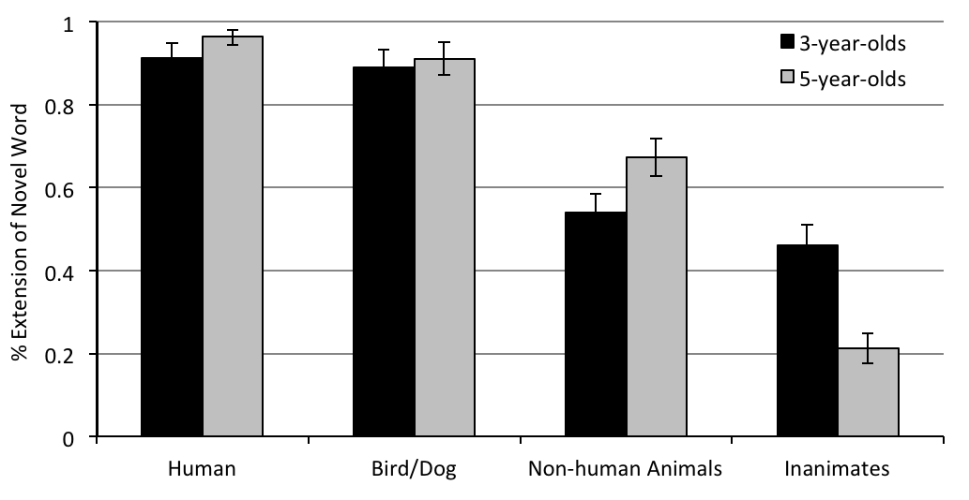
*
*
*
*
*
*
*

------------------------------------------------------------------------------------------
4. General Discussion
The current studies provide insight into 3- and 5-year-olds’ appreciation of two nested biological concepts – animal_{contrastive} and animal_{inclusive}. Building upon evidence that naming highlights category-based commonalities, the results of Experiment 1 reveal that when they are presented with two non-human animals, both 3- and 5-year-olds readily access the concept animal_{contrastive}. The fact that they do not spontaneously include humans in this grouping suggests that for preschool-aged children, humans are not prototypical animals. However, this does not preclude the possibility that they might nonetheless group humans and non-human animals together if this were called upon more directly. Experiment 2 addressed this issue. When children were presented with a human and non-human animal, 5-year-olds revealed an appreciation of animal_{inclusive}, but 3-year-olds did not.
Together, these results underscore the developmental challenge facing young children as they identify the scope of the fundamental biological term animal and its corresponding, nested concept(s). They also raise a thorny developmental question: If infants (a) appreciate two distinct sister concepts (human and non-human animal) (Bonatti, Frot, Zangle & Mehler 2002; Kuhlmeier, Bloom & Wynn, 2004; Quinn, 2004; Quinn & Eimas, 1998), and also (b) engage these two sister concepts together when reasoning about agency (Leslie, 1994; Newman, Keil, Kuhlmeier & Wynn 2010; Saxe, Tzelnic & Carey, 2007) or animacy (Baillargeon, et al., 2009; Pauen & Trauble, 2009; Shutts, Markson & Spelke, 2009), then why do 3-year-olds in Experiment 2 fail to engage the concept animal_{inclusive}?
Put differently, at issue is the status of an overarching parent concept animal_{inclusive} in infancy and early childhood. We envision several possibilities. First, perhaps animal_{inclusive} is not (yet) part of the conceptual repertoire of infants and 3-year-old children. On this view, although the sister concepts human and non-human animal may engage some of the same early intentional frameworks, it is only after age three that these are represented together under an overarching parent concept animal_{inclusive}. Alternatively, perhaps animal_{inclusive} is part of the early conceptual repertoire, but is initially accessible only in a limited set of domain-specific tasks, including for example reasoning about intentions and agency (Gergely & Csibra, 2003; Newman et al., 2010; Saxe et al., 2007; Southgate, Johnson & Csibra, 2008). On this view, it is only after age three that this overarching animal_{inclusive} can be accessed more broadly. These possibilities are consistent with the evidence that although 5-year-olds in Experiment 2 systematically extended a novel noun to humans and non-human animals, 3-year-olds failed to do so.
An important goal for future research will be to tease apart these alternatives and to identify the input conditions that best support infants’ and young children’s representation of animal_{inclusive}. In moving toward this goal, careful consideration of the language and discourse practices in which the child is immersed will be instrumental. For example, parents of young English-speaking children offer considerable support for the concept animal_{contrastive} in conversations with their 3-year-old children; they frequently use ‘animal’ to refer to non-human animals. But they offer scant support for animal_{inclusive}; only rarely do they invoke the term ‘animal’ to refer to humans (Leddon, Waxman & Medin, in press). This discourse practice, coupled with urban children’s relatively limited direct experience with non-human animals, may serve to highlight the uniqueness of humans and to fortify the distinction between human and non-human animals (Bang, Medin, & Atran 2007, Herrmann, et al, 2010; Angorro, et al., 2008), providing little support for the overarching animal_{inclusive} concept that spans them.
To pursue these issues, additional research will be required. To discover whether and how infants’ and young children’s representations of animal_{inclusive} are shaped by their communities, it is essential that we consider children raised in a wider range of linguistic and cultural communities. It will also be important to articulate more clearly the relations among key concepts, including animal_{inclusive}, animal_{contrastive ,} human and agent. Taking a cross-cultural perspective, it will be important to investigate the discourse practices pertaining to humans, non-human animals, and other animate-like kinds (e.g., robots) as well as infants’ and young children’s opportunities for direct engagement with these kinds. Such investigations will illuminate the categories to which children have ready access over development, and will clarify the evolution of these categories across development, cultural communities, and languages.

References
Anggoro, F. K., Waxman, S. R. & Medin, D. L. (2008). Naming practices and the
acquisition of key biological concepts: Evidence from English and Indonesian.
Psychol. Sci., 19(4), 314-319.
Baillargeon, R., Wu, D., Yuan, S., Li, J., & Luo, Y. (2009). Young infants’ expectations
about self-propelled objects. To appear in B. Hood & L. Santos (Eds.), The
origins of object knowledge. Oxford: Oxford University Press.
Bang, M., Medin, D. L., & Atran, S. (2007). Cultural mosaics and mental models of
nature. Proc. of the Natl. Acad. of Sci., 104, 13868-13874.
Berlin, B. (1972). Speculations on the growth of ethnobotanical nomenclature. J. of
Lang. and Soc., 1(1), 63-98.
Bonatti, L., Frot, E., Zangl, R., & Mehler, J. (2002). The human first hypothesis:
Identification of conspecifics and individuation of objects in the young infant.
Cogn. Psychol., 44, 388-426.
Coley, J. D. (2007). The human animal: Developmental changes in judgments of
taxonomic and psychological similarity among humans and other animals. Cogn., Brain & Behav. 11, 733–756.
Gelman, S. A., & Markman, E. M. (1987). Young children’s inductions from natural
kinds: The role of categories and appearances. Child Dev., 58, 1532-1541.
Gergely, G., & Csibra, G. (2003). Teleological reasoning in infancy: The naïve theory
of rational action. Trends in Cogn. Sci., 7, 287-292.
Herrmann, P., Waxman, S. R., & Medin, D. L. (2010). Anthropocentrism is not the first
step in children's reasoning about the natural world. Proc. of the Natl. Acad. of Sci., 107(22), 9979-9984.
Jipson, J., & Gelman, S. A. (2007). Robots and Rodents: Children’s Inferences About
Living and Nonliving Kinds. Child Dev., 78(6), 1675-1688.
Johnson, K. E., Mervis, C. B., & Boster, J. S. (1992). Developmental changes within the
structure of the mammal domain. Dev. Psychol., 28, 74–83.
Kuhlmeier, V. A., Bloom, P., & Wynn, K. (2004). Do 5-month-old infants see humans
as material objects? Cogn., 94, 95-103.
Leddon, E. M., Waxman, S. R., & Medin, D. L. (2008). Unmasking “alive”: Children’s
appreciation of a concept linking all living things. J. of Cogn. and Dev., 9(4), 461–473.
Leddon, E. M., Waxman, S. R., & Medin, D. L. (in press). What does it mean to 'live' and
'die'? A cross-linguistic analysis of parent-child conversations in English and
Indonesian. British J. of Dev. Psychol.
Leddon, E.M., Waxman, S.R., Medin, D.L., Bang, M., & Washinawatok, K. (under
review). One animal among many? Children’s understanding of the relation
between humans and nonhuman animals.
Leslie, A. M. (1994). ToMM, ToBY, and Agency: Core architecture and domain
specificity. In L. A. Hirschfeld & S. A. Gelman (Eds.), Mapping the mind:
Domain specificity in cognition and culture (pp. 119-148). New York:
Cambridge University Press.
Luo, Y., Kauffman, L., & Baillargeon, R. (2009). Young infants’ reasoning about
physical events involving inert and self-propelled objects. Cogn., 58(4), 441-486.
Massey, C., & Gelman, R. (1988). Preschoolers’ ability to decide whether a
photographed unfamiliar object can move itself. Dev. Psychol., 24(3), 307-317.
Newman, G. E., Keil, F. C., Kuhlmeier, V. A., & Wynn, K. (2010). Early understandings
of the link between agents and order. Proc. of the Natl. Acad. of Sci., 107, 17140-17145.
Opfer, J. E., & Gelman, S. A. (2010). Development of the animate-inanimate distinction.
In U. Goswami (Ed.),Wiley-Blackwell Handbook of Childhood Cognitive Development (pp. 213 - 238).
Pauen, S., & Trauble, B. (2009). How 7-month-olds interpret ambiguous motion
events: Category-based reasoning in infancy. Cogn. Psychol., 59(3),
275-295.
Quinn, P. C. (2004). Is the asymmetry in young infants' categorization of humans
versus nonhuman animals based on head, body, or global Gestalt Information? Psychon. Bull. & Rev., 11, 92-97.
Quinn, P. C., & Eimas P. D. (1998). Evidence for a global categorical
representation of humans by young infants. J. of Exp. Child Psychol., 69(3), 151-74.
Rhodes, M., & Gelman, S. A. (2009). A developmental examination of the conceptual
structure of animal, artifact and human social categories across two cultural
contexts. Cogn. Psychol., 59, 244-274.
Saxe, R., Tzelnic, T., & Carey, S. (2007). Knowing who-dunnit: Infants identify the
causal agent in an unseen causal interaction. Dev. Psychol., 43, 149-158.
Shutts, K., Markson, L., & Spelke, E. S. (2009). The developmental origins of animal
and artifact concepts. In B. Hood & L. Santos (Eds.), The origins of object knowledge. Oxford: Oxford University Press.
Slaughter, V., & Lyons, M. (2003). Learning about life and death in early childhood.
Cogn. Psychol., 46(1), 1-30.
Southgate, V., Johnson, M. H., & Csibra, G. (2008). Infants attribute goals to even
biologically impossible actions. Cogn., 107, 1059-1069.
Waxman, S. R. (1989). Linking language and conceptual development: Linguistic
cues and the construction of conceptual hierarchies. Genet. Epistem., 17(2), 13-20.
Waxman, S. R. (2005). Why is the concept "Living Thing" so elusive? Concepts,
languages, and the development of folkbiology. In W. Ahn, R.L. Goldstone, B.C.
Love, A.B. Markman, & P. Wolff (Eds.), Categorization Inside and Outside the
Laboratory: Essays in Honor of Douglas L. Medin. Washington, DC: American
Psychological Association.
Waxman, S. R., & Gelman, S. A. (2009). Early word-learning entails reference, not
merely associations. Trends in Cognitive Sciences, 13(6), 258-263..
Waxman, S. R., Lynch, E. B., Casey, K. L., & Baer, L. (1997). Setters and samoyeds:
The emergence of subordinate level categories as a basis for inductive inference. Dev. Psychol., 33(6), 1074-1090.
Waxman, S. R., & Markow, D. B. (1995). Words as invitations to form categories:
Evidence from 12-month-old infants. Cogn. Psychol., 29, 257-302.
Waxman, S. R., Medin, D. L., & Ross, N. (2007). Folkbiological reasoning from a cross-
cultural developmental perspective: Early essentialist notions are shaped by
cultural beliefs. Dev. Psychol., 43(2), 294-308.
Welder, A. N., & Graham, S. A. (2001). The influence of shape similarity and shared
labels on infants’ inductive inferences about nonobvious object properties. Child Dev., 72, 1653-1673.
Winkler-Rhoades, N., Medin, D. L., Waxman, S. R., Woodring, J., & Ross, N. O.
(2010). Naming the animals that come to mind: Effects of culture and experience on category fluency. J. of Cogn. and Cult. 10, 205-220.

We impose the following convention to distinguish between the word (‘animal’) and the concept to which it refers (animal).
Here, and in Experiment 2, all contrasts used Bonferroni corrections
The GEE analysis for Experiments 1 and 2 are available from the first author upon request.
Adopting this stringent criterion is essential if we are to distinguish the animal-contrastive from the animal-inclusive pattern. Because these two patterns differ only in treatment of the (3) human test items, permitting more than one error would make it impossible to differentiate them.
As in Experiment 1, co-efficient alphas revealed that internal consistency was high: humans (α=0.88), non-human animals (α=0.86), inanimates (α=0.89).

