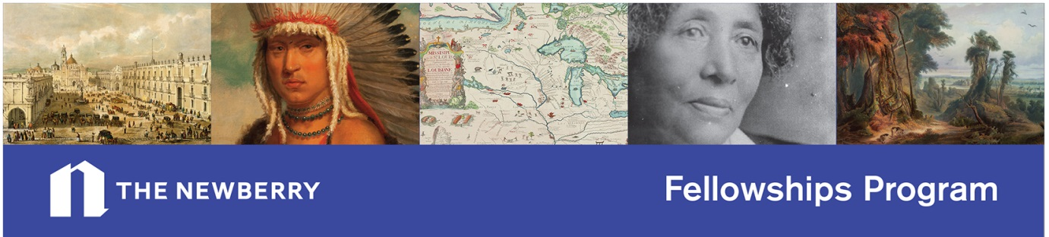
The deadline to apply for a short-term fellowship is quickly approaching!
All applications must be submitted by 11:59 PM CST on December 15, 2015.
*Please note our new deadline for the 2016-17 academic year.
Newberry Library Fellowships provide support to researchers who wish to use our collection. We promise intriguing and often rare materials from our world-class collection; a lively, interdisciplinary community of researchers; individual consultations with curators, librarians, and other scholars; and an array of both scholarly and public programs.
The Frances C. Allen Fellowship is designed for women of American Indian heritage. While candidates for this award may be working in any graduate or pre-professional field, the particular goal of the Allen Fellowship is to encourage American Indian women in their studies of any field related to the Newberry's collection. Allen fellows are expected to spend a significant part of their tenure in residence at the Newberry's D'Arcy McNickle Center for American Indian and Indigenous Studies. The tenure of the fellowship is from one month to one year with a stipend of $2,500 per month; supplemental funding may also be available on a case by case basis. Applicants must fill out a supplementary form in addition to the application webform.
The Susan Kelly Power and Helen Hornbeck Tanner Fellowship for PhD candidates and postdoctoral scholars of American Indian heritage supports one or two months of residential research in any field in the humanities using the Newberry collection. Applicants for this fellowship need not be from outside the Chicago area. Applicants must fill out a supplementary form in addition to the application webform.
The Newberry Consortium in American Indian Studies Faculty Short-Term Fellowship is a one-month fellowship opportunity that is designed for faculty members at institutions participating in the consortium. Fellows will work on a project in American Indian Studies requiring research in the Newberry's collections. The stipend for this fellowship is $5,000.
The Newberry Consortium in American Indian Studies Graduate Student Fellowships supports PhD candidates at institutions participating in the consortium. Fellowship recipients are expected to present their research at the consortium's annual graduate student conference or at a Newberry-sponsored seminar in American Indian and Indigenous Studies. These travel-to-collections grants offer support for one to two months of dissertation research. Awards may be used to fund research at the Newberry or at other research venues. Applicants from Chicago-area member institutions are eligible for this award. Applicants for the NCAIS Graduate Fellowship must fill out a supplementary form in addition to the application webform.
For more information, visit our website at www.newberry.org/fellowships

